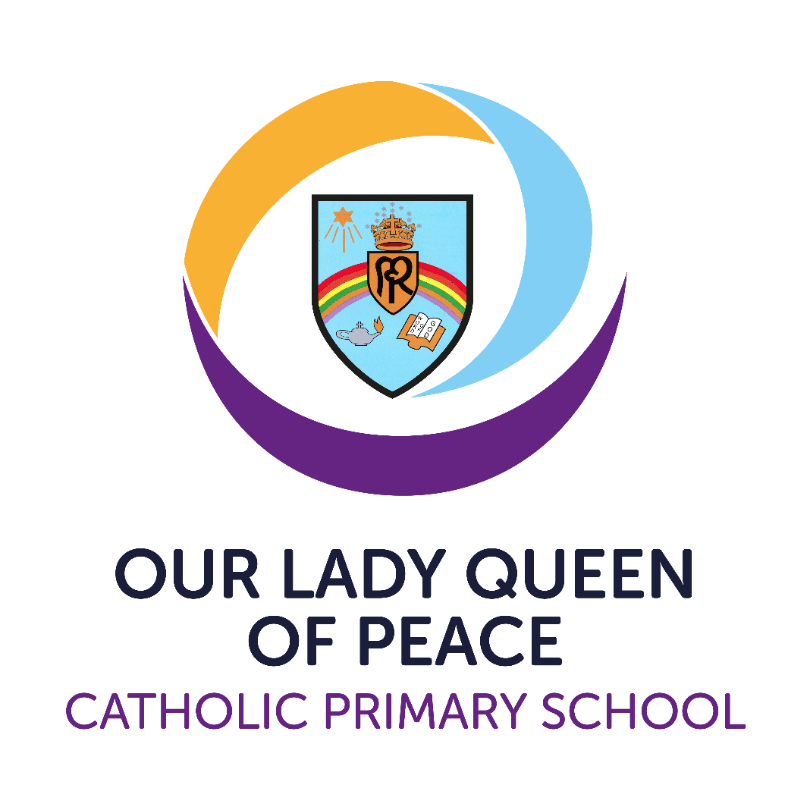
Prayer and Liturgy Policy

Version | 1
Date created/updated | 16th September 2025
Ratified by | Local Governing Body
Date ratified | September 2025
Date issued | September 2025
Policy review date | September 2027
Post holder responsible | (Executive) Principal
Director / LGB Chairperson | Ben Sheehy

Commitment to Equality:
We are committed to providing a positive working environment which is free from prejudice and unlawful discrimination and any form of harassment, bullying or victimisation. We have developed a number of key policies to ensure that the principles of Catholic Social Teaching in relation to
human dignity and dignity in work become embedded into every aspect of school life and these policies are reviewed regularly in this regard.
This policy has been approved and adopted by Our Lady Queen of Peace Catholic Primary School on 16th September 2025 and will be reviewed in September 2026.

Signed by LGB representative for Our Lady Queen of Peace: Ben Sheehy

Signed by (Interim Executive) Principal: Anthony Wilkes

The Nature of prayer and liturgy
Ministries (e.g., readers, altar servers, cantors, musicians, those who prepare the space) serve the prayer and liturgy and receive appropriate formation.
The whole school gathers as a liturgical assembly; staff model good participation alongside pupils.
We foster full, conscious and active participation appropriate to age and capacity.

Participation and Ministries
Liturgy: celebrations taken from the Church’s liturgical books (e.g., Mass, Reconciliation, Liturgy of the Hours).
Celebration of the word: a structured gathering (e.g., an assembly) centred on the proclamation of Scripture; may draw on liturgical symbols and gestures.
Prayer: the lifting up of hearts and minds to God; communal prayer is an essential part of Catholic school life.

Definitions (as guided by the Prayer & Liturgy Directory, 2023)
At Our Lady Queen of Peace Catholic Primary School (OLQP) we believe that Christian worship in a Catholic school is concerned with giving glory, honour, praise and thanks to God. It is our loving response, in word and action, to God's invitation to enter into relationship, made possible through the work of Jesus Christ and the witness of the Holy Spirit.

Legal Requirements
Within Catholic schools, the Bishops’ Conference has replaced the term ‘collective worship’ with ‘prayer and liturgy’. We maintain the statutory requirement for a daily act of worship, but in policy, planning and evaluation we refer to ‘prayer and liturgy’ and its distinct forms (e.g., Mass, Reconciliation, celebration of the word, classroom prayer).
We acknowledge the legal requirement that there must be a daily times of prayer and liturgy for all pupils. This can take place at any time during the school day and can be either a single times of prayer and liturgy for all pupils, or separate times of prayer and liturgy in school groups e.g. Key Stage celebrations of the word (assemblies). We understand that simply holding an celebration of the word (assembly) that includes a prayer, said either by the teacher or everyone present, does not fulfil this requirement. We also acknowledge that prayer and liturgy and celebration of the word (assembly) are distinct activities. They may sometimes form part of the same gathering, but the difference between the two will always be made clear.

The times of prayer and liturgy is not designated curriculum time under regulations and will not be subsumed under any part of the curriculum, including Religious Education. celebrations of the word (assemblies), where teaching and learning take place, may be included as part of the RE curriculum on occasion.

At OLQP, responsibility for arranging a timetable of prayer and liturgy rests with the Governing Body in consultation with the Head Teacher.

The Place of prayer and liturgy in the Life of our School
We endorse the belief that prayer and liturgy considers the religious and educational needs of all who share in it:
• Those who form part of the worshipping community in Church;
• Those for whom school may be their first and only experience of Church;
• Those from other Christian traditions, or none;
• Those from other faith backgrounds. It will be an educational activity or experience to which all can contribute and from which all can gain.

Prayer and liturgy in OLQP is an integral part of school life and central to the Catholic tradition.

The Aims of prayer and liturgy
We believe that prayer and liturgy in our school community will provide a variety of opportunities to deepen our relationships with God and develop the following:
• contemplate the mystery of God;
• unite our worshipping liturgical assembly;
• develop the necessary skills of reverence, contemplation, reflection, interpretation, empathy, meditation which will enable our relationships with God to be deepened.

Full participation in our faith will allow us:
• To grow in spiritual, moral, cultural and liturgical understanding;
• To grow in understanding of our living faith tradition;
• To develop a sense of awe, wonder and inspiration in the person of Christ;
• To examine and reflect upon our own individual faith journeys;
• To develop the skills of prayer.

Implementation
All times of prayer and liturgy should: -
• Give glory and praise to God;
• Be structured to ensure a quality experience for all participants;
• Be kept to the point (and brief wherever possible);
• Be clear in their liturgical focus and varied in their delivery;

Prayer and liturgy in our school may follow the pattern or variation of the pattern detailed below:

Common structure for celebrations (adapted for context): Gather – Listen – Respond – Go Forth.
Gather - how we come together, the setting, the environment (quiet/ reflective music, lighted candles, statues, sat in a different format, sign of the cross, focus and examination of conscience etc);

Listen - a reading from the Scriptures, breaking the word, time to reflect on this and prayers to fit into the theme;

Respond - reflection time, prayer, discussion around the theme of the Scripture, silence or hymns.

Go forth (mission) - the sending out from the celebration, giving the children something to hold onto from the experience of the liturgy that they can take into their daily lives.

Prayer and Liturgy takes place:

Day | Focus
Monday | Whole School Gospel Liturgy
Tuesday | Fortnightly – Whole School Mass in Church, led by a particular Class  Fortnightly – Whole School Singing Prayer and Liturgy
Wednesday | Phase Prayer and Liturgy (YR Y1 Y2, Y3 and Y4, Y5 and Y6)
Thursday | Key Stage 2 – Gifts of God Prayer and Liturgy  Reception and Key Stage 1 - individual Class Prayer and Liturgy
Friday | Reception and Key Stage 1 – Gifts of God Prayer and Liturgy  Key Stage 2 - individual Class Prayer and Liturgy

Throughout the year each class is involved in planning and leading regular liturgies and Masses.

prayer and liturgy will also be celebrated through:
- Daily class prayers at the beginning and end of the day and before and after lunchtime
- Whole school Mass
- Whole school Mass on Holy Days that fall within the school term
- School led celebrations in church e.g. Harvest Festival and Candlelight Service
- Advent and Lent reflections
- Liturgical presentations such as Nativity, Passion Play.

Class Saints
As a reminder that we are called to be saints and live a life of holiness, each class has a class saint to inspire them on their journey in faith.
The children learn about their class saint's life, why they are a good role model and how, through their example, we might become closer to Christ ourselves. This gives our children the opportunity to know about the life and work of a variety of saints during their time at OLQP.
Reception – St Mary
Year 1 – St Joseph
Year 2 – St John Bosco
Year 3 - St Teresa of Calcutta
Year 4 – St Josephine Bakhita
Year 5 – Blessed Carlo Acutis
Year 6 – St Maximillian Kolbe

The Planning, Content and Delivery of prayer and liturgy
prayer and liturgy is planned:
- following a structure with reference to the Liturgical Calendar, significant dates and the scripture will be the focus in most acts of worship
- involving consultation with appropriate parties and reference to school aims and policies
- with flexibility to respond to changing situations within the class, school and the wider community
- to develop in pupils’ skills that enable them to prepare, organise and lead worship (See Appendix 1)
- to mark significant events such as a silent reflection on Armistice Day
- to give praise to God through art, dance, music and prayer
- to encourage the active participation of all

Celebration of the Eucharist
This takes place fortnightly for the whole school in Church and for holy or
celebratory days when within term time. Parents and parishioners are welcome
to attend these Masses and the dates are shared with parents, and on the Parish newsletter. Children taking part in the liturgy are well prepared by practising in advance
in school and supported by their parents at home. At these Masses children have the opportunity to take part in liturgy, offertory, altar serving and singing.

The Catholic Curriculum

Through the development of a Catholic Curriculum all staff have the knowledge and understanding of the Catholic Social Teaching themes. Staff ensure that through the Prayer and Liturgy there are opportunities for the pupils to develop their own knowledge and understanding of the key principles of the Catholic Social Teaching themes. Pupils are also encouraged to use this gained understanding to make age-appropriate links to their everyday lives and the world around them. The CAFOD resources are used to support this learning and it is also enhanced through trips, visitors to school and experiential days as well as involvement in charitable organisations.

The Catholic School Pupil Profile is also linked to the Catholic Curriculum and the appropriate virtues are chosen and celebrated through the Prayer and Liturgy. The virtues are:

• Grateful & Generous

• Attentive & Discerning

• Compassionate & Loving

• Faith-filled & Hopeful

• Eloquent & Truthful

• Learned & Wise

• Curious & Active

• Intentional & Prophetic

Recording
prayer and liturgy is recorded through written reflections, collections of pupils' contributions, prayers, tweets and children’s work. Each Class has a Prayer and Liturgy folder which contain pupil evaluations (as a leader of liturgy and a participant Appendix 2 and 3).

Monitoring and Evaluation
The following will be monitored:
• Time set aside for prayer and liturgy;
• Whether the observed practice is consistent with agreed policy;
• Whether prayer and liturgy is resourced in terms of materials, visual aids etc;
• Staff development on prayer and liturgy and its impact;
• Prayer focus and its effectiveness in drawing pupils into prayer;
• Impact on pupils and members of the school community;
• Opportunities for pupils to develop the necessary skills to access worship and prayer;

Resources
Each class teacher is responsible for maintaining a class RE display and prayer area linked to the unit of work and liturgical calendar. Pupils have access to a Class Prayer and Liturgy box from which they can choose appropriate resources to plan and lead worship.

The Headteacher and RE Coordinator are responsible for providing training and support to enable teachers and pupils to plan and lead meaningful prayer and liturgy.
Appendix 1

Children Leading Prayer and Liturgy Progression

Teachers need to prepare and lead most times of prayer and liturgy and be an excellent role model for children to emulate. Teachers should withdraw input gradually at the appropriate time depending on the age and stage of development of the children. Children leading worship should never detract from it being an enriching experience where glory, honour and praise is given to God.

KEY STAGE ONE
At this stage, in most times of prayer and liturgy the teacher will lead and model Prayer and Liturgy. At this age, children are facilitating worship rather than leading it. They may lead certain parts/elements.

Reception
Children may
- Sing a gather song
- Make the Sign of the Cross
- Choose artefacts from a limited selection
- Greet everyone
- Set up Prayer table
- Lead prayers
- Say what they want to pray for

Year 1
As Reception plus
- Choose artefacts from a wider selection
- Given the theme, choose an appropriate way to gather or go forth from a limited selection - Teacher to help

Year 2
As Year 1 plus
- Can explain the purpose, theme and focus of the prayer and liturgy
- From a selection, choose one suitable element (Gather, Listen, Respond & Go forth) for the Collective Worship

KEY STAGE TWO
In Key Stage 2, teachers still need to show the children how to prepare and deliver Prayer and Liturgy. Teachers and pupils work together at first to prepare the collective act. Teachers gradually withdraw support allowing pupils to take more of a lead. Teachers should provide themes and scripture and oversee the children’s efforts before delivery.

Years 3 & 4
All of Year 2 plus…
- Provide a suitable focus. They understand their choice and make appropriate use of Liturgical colours. - Lead singing
- Work ICT equipment
- Write prayers and petitions that fit the theme of the prayer and liturgy.
- Choose suitable ways to Gather, Listen, Respond and Go Forth

Years 5 & 6
All of Years 3 & 4 plus…
- Given a set theme can now select appropriate Scripture passages (initially from a limited selection)
- By the end of Y6, pupils should be able to develop all parts of prayer and liturgy independently with understanding when given a theme or a passage from the scripture.

Appendix 2

Evaluation of Prayer and Liturgy (Participant YR / KS1 and KS2)

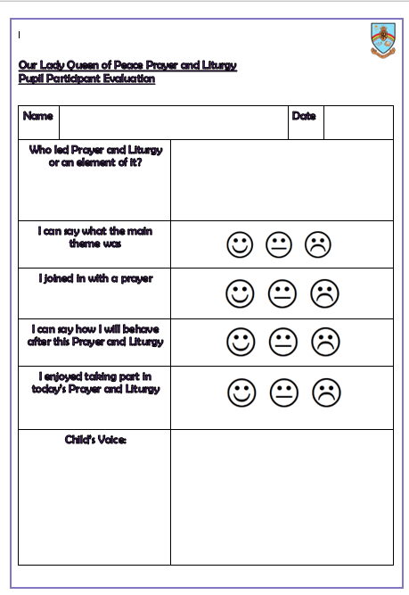

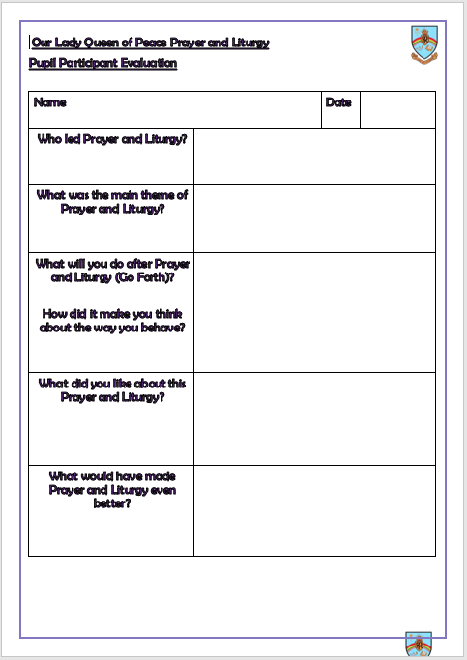

Appendix 3
Evaluation of Prayer and Liturgy (Leader YR / KS1 and KS2)

